**Pita Dubuque LLC**



**185 Main, Dubuque, IA 52001**

**Jonathan Goodfellow**

**Juliana Lancheros Mantilla**

**Ryan P. McCarty**

**Stephanie A. Kramer**

**Index**

* Executive Summary …………………………………………………………………..Pg: 3

1. Business Status…………………………………………………………. ………..Pg: 3
2. Location …………………………………………………………………………. Pg: 3
3. Structure …………………………………………………………………………. Pg: 3
4. Type of Business ……………………………………………………………...… Pg: 3
5. Mission Statement …………………………………………………………….… Pg: 3
6. Long-term Goals ………………………………………………………………… Pg: 4
7. Description of Products and Services ……………………………………..………Pg:4
8. Opening Date ……………………………………………………………….…… Pg: 5
9. Management Team ……………………………………………………………… Pg: 5

* Marketing Research and Analysis ……………………………………………………Pg: 6

1. Customer Description …………………………………………………………… Pg: 6
2. Market and Industry Analysis ………………………………………………….…Pg: 8
3. SWOT Analysis……………………………………………...……………………Pg: 9
4. Competitive Analysis……………………………………...…………………… Pg: 11

* Marketing Plan…………………………………………………………….………… Pg: 13

1. Marketing Objectives………………………………………………………….… Pg: 13
2. Products/Services and Pricing………………………………………….…………Pg: 15
3. Promotion ……………………………………………………………...……...… Pg: 16
4. Ongoing Marketing Evaluation ……………………………………………...……Pg:19

* Operations………………………………………………………………….…………Pg: 19

1. Business Operations…………………………………………………………...… Pg: 19
2. Facility…………………………………………………………………...……… Pg: 22
3. Office Equipment…………………………………………………………...…… Pg: 23
4. Suppliers……………………………………………………….………………… Pg: 23

* HRM………………………………………………………………………….……… Pg: 23

1. Local Labor Market Conditions…………………………………………..………Pg: 23

* Financial Plan………………………………………...……………………………… Pg: 24

1. Start-Up Costs…………………………………………………………………… Pg: 24
2. Accounting and Bookkeeping Systems…………………………………...………Pg: 25
3. Sales Forecast…………………………………………………………….……… Pg: 25
4. Financials …………………………………………………………………….…..Pg: 25

* Appendix ……………………………………………………………...…………….. Pg: 28
* Works Cited ……………………………………………………………………….. Pg: 44

**Executive Summary**

1. **Business Status:**

The owners of Pita Dubuque LLC plan to open a Pita Pit franchise in Dubuque, Iowa on April, 12 2014.

1. **Location:** The owners plan to place the Pita Pit franchise in 185 Main Street Dubuque, Iowa 52001.
2. **Structure of the company:**

**Corporation – LLC** Pita Pit Dubuque is going to be a Limited Liability Company. LLC’s have the tax advantages of partnerships, with the limited liability advantages to their shareholders. They have the single tax benefits of S-Corporations, without the complications of such tax status. Members may be actively involved in the business or delegate responsibilities to managers.

1. **Type of Business:** retail, wholesale, service, manufacturing, contracting, professionalPita Pit is an innovative, rapidly expanding, healthy quick service restaurant franchise. Founded by Nelson Lang, Pita Pit has a new and unique approach. The goal is to offer quality, healthy, fresh food – fast! With a friendly, informal atmosphere and a varied and tasty menu selection the idea caught on. The first Pita Pit opened in 1995 in University town of Kingston, Ontario, Canada to great success. In 1997 recognized this new trend, Nelson set out on a journey that would see restaurants open across Canada and the US and now throughout the world.
2. **Mission Statement:** *“To change people’s lives - on BOTH sides of the counter”* Nelson Lang – Founder.
3. **Long-term Goals:** Pita Pit Dubuque plans to be a stable long term player in the fast service restaurant industry. The owners intend on it being one of the leader caterers in the Tri-State area.
4. **Description of the products and services:** With the move towards low carbohydrate and reduced fat diets, sandwich break and pizza crust are losing their popularity. While the Pita shell is light and tasty, it is not the meal – it is the delivery mechanism. Inside the shells are the fresh topping and low-fat protein people seek. Salads, all – day breakfast Pitas, coffee, smoothies, and yummy extras are also available at select locations. Customers are served quickly. Pita Pit restaurant are open late where demand prevails. There is a very little packaging, just a paper wrapper, and customers can eat “on-the-run.” The customer sees real meat put on the grill. No fryers and no convention oven cooking. The taste of grilled meat is like no other and the aroma attracts customers and builds anticipation for real meal. Pita Pit Inc. has invested heavily in establishing a unique and attractive brand. Pita Pit communicates its distinctiveness with an ensemble of tools, from the specially developed Pita shell, to the menu and colorful menu boards, and Petey. The innovative way we roll Pitas makes for a different and exciting eating experience. Owners develop a relationship with their customers. Each Pita is made carefully to the customer’s specifications and delivery with our select ***P.I.T.A.*** principles (**Play, Initiate, Tantalize, Attitude**). Pita Pit is a fun place to be. Meat and veggies sizzling on the grill, bold colors, lighting, music and décor. Pita Pit offers a special atmosphere and experience that customers come back to. Pit Pit is THE new quick service trend. As the best improvement in the health-food evolutionary chain – we are beyond burgers, fries, pizza and subs. Pitas are exotic. Pita Pit is a cool place where the staff knows your name. We embrace youthful exuberance.
5. **Opening date:** We will be opening in May of 2014 due to the high sales we hope to earn during the summer months. There are two main reasons why we decided to open the business this year. First, because all of the entrepreneurs will be officially done with school by then and therefore they will be able to focus more in all the aspects of the business. Second, we believe the economy will be much better next year and we might be able to get better rates for our loan and hopefully our investors will be in an even better economic situation.
6. **Management Team:**

Executive Chief Operations Office and General Manager: Jonathan Goodfellow. Senior graduating with a degree in Business Management, Marketing with a concentration in International Businesses. He focused specifically in Supply Chain Management and Operations. Be in charge of the overall functionality of the company. Once our business opens, he will remain as the manager and oversee all daily operations.

Chief financial Officer: My name is Juliana Lancheros and I am a Business Management and Finance double Major with a Minor in Psychology graduating in May 2014. I have been in charge of the financial side of the business plan. This has included the initial budget, owner’s equity, loans, long-term or short-term financial goals and our startup costs.

HR Manager: Ryan McCarty, Business Management, International Studies double Major with a Minor in Psychology. He has focused on the management and HR side of the business plan. This has included hiring work force, where Pita Pit will be located, competitors and barriers to entry.

Chief Marketing Officer: Stephanie Kramer and I am a Marketing and Management double Major with a Minor in Computer and Information Technology. I have been in charge of the marketing side of the business plan. This has included ideas like to whom are we going to sell, what product, where and at what price? I have also looked at the segmentation, positioning, and tactics of our Pita Pit.

**Market Research and Analysis**

1. **Customer Description**

There are a total of 57,537 people within the Dubuque City Township. There are 27,910 males and 29,727 females, with 12,361 people under 18 and 45,276 18 and over. The primary target market will be college students and professionals working in the downtown area. These patrons would be between the ages of 20-50. This accounts for 22,497 of Dubuque City Township’s population. (Census) Dubuque has an unemployment rate of 6.5%, nearly half the national average and a median household income of $48,779. As Dubuque is located in a Tri-State Area, customers will not only come from Iowa, but they might also come from Illinois or Wisconsin. The mean travel time to work is 14.9 minutes for workers of ages 16 years old and up. Dubuque is the main commercial, industrial, educational, and cultural center in this area which means that a significant amount of people who live in East Dubuque, Peosta, Galena, Bellevue, Key West, Asbury, Dyersville, Epworth, Cascade, among other cities work in Dubuque in businesses such as IBM, John Deere, Colony Brand Inc., Cottingham & Butler, Diamond Jo Casino, Dupaco Community Credit Union, DuTrac, Dubuque Bank and Trust, US Bank, American Trust, Heartland Financial USA, Inc, Hills & Dales, McGraw-Hill, A.Y. McDonald, University of Dubuque, Clark University, NICC, and Loras College.Only 2.6% of Dubuque’s population spends an hour or more getting to work, which means that probably most of the labor force in Dubuque works in Dubuque. (Forbes) Therefore, our target market is even bigger than just the Dubuque population.

According to other franchisees, such as the one in Mason City, Sioux City, and Flagstaff their target market is everyone except children[1], more specifically gear towards college students and men and women professionals. Do not necessarily housewives, because they will most likely cook at home for themselves, their children, and husbands on a daily basis. To avoid this issue of mothers or fathers staying in, Pita Pit has deliveries as well within 10 miles of the store location. The percentage of women in the labor force in Dubuque is 64.25 and of men is 74.12 as of 2010[2]. The difference is not that big and it tells us that men and women have basically equal access to Pita Pit Dubuque, IA. People in the working force in Dubuque, work mostly from 8:00am to 5:00pm in most businesses. From their schedule they will most likely have an hour of lunch break between 11:00am to around 1:00pm where Pita Pit services will be available.

According to other references, the number of women who access Pita Pit in higher in the morning and early-afternoon, while more men go to Pita Pit in the late-afternoon and in the evening. As this business will be located in the downtown area and according to studies and statistics made, Dubuque is only 24% safer than other cities in the United States[3]. This is an indicator of why the demographics of customers changes throughout the day. As our franchiser specifies in the franchisee booklet that everyone is our target market, we still need to take into account that families might actually be our target market during the weekends. Even though two children might eat the same quantity as one adult, they are still part of our customers as well as their parents. Around 21% of Dubuque’s population is under the age of 18, but this does not mean that they cannot eat at Pita Pit.

1. **Market & Industry Analysis**

According to the Technomic U.S. Foodservice Industry Forecast for this current year 2013, the nominal growth in the Foodservice Industry will be about 4% in restaurants and bars. The downside of it is that the price of the ingredients in the Foodservice Industry is going up, which affects costs highly. Pita Pit partners with suppliers like Sysco and Tyson to ensure both high quality and consistency across all Pita Pit locations. The franchiser does not impose prices on the franchisees; instead it sets suggested retail prices. When ingredients costs go up, Pita Pit tries to minimize what must be passed on to customers. One approach by the competitors is to substitute inferior products that are less expensive. This company never does that; it never would consider compromising on quality. What it does is to try to work with its suppliers to be as cost-effective as possible and use whatever savings it can achieve to hold down pricing on the other end.

**SWOT Analysis**

Strengths

Pita Pit is a healthy alternative for fast food. There are also many locations across the United States and is even international. There are a total of 7 locations in Iowa: Iowa City, Ames, Waterloo, Sioux City, Mason City, Ankeny, and Coralville. Pita Pit is also a great late night option, with all locations staying open until 3:00 am Thursday through Saturday. If customers don’t feel like going out of the house they can choose the delivery option. Pita Pit’s customers also have a rewards program they can choose to be in. The program called “The Pit Card” is both a gift card and reward card wrapped in one. Customers can use these cards to upload money onto it and can either choose to give them as gifts or keep them for themselves. $1 spent is $1 earned towards the reward card. Pita Pit’s target market is everyone except kids, but more focused on college students and businesses in the downtown area. Therefore, they are educated about getting the most for their dollar and are spending their money wisely. The Pita Card[4] is a great option for college students, because they want to save money in any way they can. Earning rewards points will make them more inclined to want to come back and spend their points. This is also an excellent option for business professionals, because eating out on their lunch break everyday can add up and thus The Pita Card is useful for them as well. This is not only a fast and healthy option for them, but they also receive reward points in return.

Weaknesses

A weakness Pita Pit has is the amount of seating it offers. The seating can be limited at times, especially during busy hours. The company values its customers and wants to make sure they are comfortable in the restaurant. Thus, seating is something the company can work on improving to satisfy their customers even more.

Opportunities

The restaurant has the opportunity to make a big impact in the Dubuque area. Pita Pit can advertise by having radio and television commercials as well as placing billboards in the busiest places in Dubuque. This location is also going to give free Pita’s to various companies near the restaurants location in downtown Dubuque in order to give more awareness to those companies employees. The company has the opportunity to gain customer loyalty by having various types of promotions and rewards. There is the opportunity to have customers receive a free drink if they have a rewards card. Pita Pit has the chance to be the fastest fast food restaurant by being aware of the busiest times and making sure they schedule more workers during those hours. The late night options are also an opportunity for Pita Pit to gain customers by having the restaurant in locations near bars. Having a healthy lifestyle is also extremely important, because it not only makes one look better, but feel better as well. Dubuque realizes this lifestyle which is why it has 12 fitness centers in the area. Many companies are starting to form wellness groups and encourage their employees to start eating healthy and working out. Pita Pit will be a great opportunity for them to start eating healthy, because it is fast and convenient. People often do not have enough time to work out and thus focus more on eating healthy. There is a stigma that eating healthy is boring and the food is bland, which is the exact opposite of Pita Pit. Pita Pit has the opportunity to open people’s eyes and help them realize that eating healthy can be fast and tasty at the same time.

Threats

Pita Pit’s main threats and competition are Jimmy Johns, Pickle Barrel, Falbos, and Lot One in downtown Dubuque. Jimmy Johns and Pickle Barrel are both fast food yet healthy choices for customers to choose near Pita Pit’s location in Dubuque. These restaurants have been established in Dubuque for quite some time and thus have already developed loyal customers. Falbos is another fast food option for customers to choose from in downtown Dubuque and is therefore a threat for Pita Pit as it opens its doors for the first time. Lastly, Lot One serves Pita’s already along with an assortment of other food choices. This is a threat for the company, because even though it may be the first Pita Pit in the city, it is not the first restaurant to serve Pita’s.

1. **Competitive Analysis**

* Jimmy John’s[5]

When looking at our competitive analysis and who are main competitors are, it is crucial to first examine similar competitors in close proximity, such as Jimmy Johns. Jimmy Johns has 2 locations in Dubuque, one on John F. Kennedy Rd and the other on Main Street. The location on Main Street is a little over a block away (refer to appendix) and poses an immediate threat. Here is some basic facts about owning a Jimmy Johns franchise:

* + - Total estimated initial investment 305,000-480-000
    - 285,00 average net profit
    - 26% average food and paper costs

Jimmy Johns, just like Pita Pit, boasts about their fresh ingredients and healthy options. It is our task though our marketing efforts and customer interaction to re-iterate how our product is different while exceeding consumer expectations when it comes to freshness. It is our firm belief that customers will prefer our clean and energetic environment. We also know that we can effectively gain a large amount of the customer base in the Main Street area due to our marketing strategy and due to our late hours.

* + The Dubuque area has nearly 10,000 college students and one of our main goals is to garner a strong customer base among these students.
  + On the weekends we will be open late in order to cater to the always bustling nightlife in the main street area. With numerous bars within feet of our restaurant, we know that we can attain the bar crowd, since Jimmy Johns is not open late.
  + Jimmy Johns prices range from $3.45- $7.89
* Picket Barrel

Pickle Barrel Subs is another one of our main competitors, due to their location on Main Street and their similar product. They are a small franchise with a very limited number of locations in the Midwest, so they are lacking in knowledge base and credibility. They state that “Whether you are a regular or someone just passing through, we are ready to show you why Pickle Barrel is so much more than just a sandwich.”

* Subway

Subway is another potential competitor because of their healthy sandwich menu, but due to their locations in Dubuque we won’t be focusing on them. There are also details regarding all of our potential competitors in the appendix including Panera Bread, Jason’s Deli, and Noodles and Company.

**Marketing Plan**

1. **Marketing Objectives**

Pita Pit’s objectives are to get their name out to as many people as possible in the shortest amount of time. This is going to be done through advertisement on local television and radio stations, billboards, and talking to big businesses in the area as well as colleges. The advertising will be done on Mediacom on the local stations, specifically during the night time hours. Most people are working during the day and watch the majority of TV at night, which is why Pita Pit’s prime advertising hours will be between 5:00pm and 11:00pm.

Pita Pit will also have a 30 second radio commercial on local stations such as Y105, WJOD, WLLR, and KATFM. The prime hours to reach consumers will be when they are on their way to work and on their way home from work. Thus, the main hours will be 7:00 am to 8:00 am and 4:00pm to 6:00 pm. Some consumers may be in a hurry to get home and not have enough time to make food and decide to go to Pita Pit when they hear their commercial. They may than tell their friends and family about their food and therefore advertises Pita Pit through word of mouth. This is great for the company, because word of mouth is free advertisement.

Billboards are also a main component in achieving Pita Pit’s marketing objectives. Pita Pit has looked at Dubuque’s traffic counts and has concluded that the heaviest traffic is by the Airport, downtown by NICC, JKF, Asbury, and University Avenue. Therefore, it is important to put billboards in those areas to reach the greatest number of people. Lamar, the main billboard company in Dubuque, has various options to choose from. There is the digital billboard that constantly changes throughout the day as well as the standard billboard. The digital billboard is priced on a weekly basis whereas the standard billboard is priced on a 4 week basis. Lamar also rotates their billboards within that time period which is an awesome attribute, because it is reaching an even greater audience.

Pita Pit is also advertising by talking to the various big companies that are located near the location in downtown Dubuque. This is a big target area, because most of the area located near Pita Pit will consist of businesses. It is important that they are aware of the new store and thus tell their employees about the restaurant. Pita Pit can hand out cards with their information on them such as store hours and the delivery number. They can also deliver free pita’s to these businesses in order to show them what the product is all about. They can set menu’s in the break rooms where everyone can see them as well as pass out coupons. The coupons will be for a free drink with a purchase of a Pita. This will raise awareness to the consumer and thus get them in the door. They will be greeted by Pita’s friendly employees and see the cleanliness of the restaurant. All of this combined will hopefully make the consumer come back again to enjoy another pita.

Lastly, Pit Pita realizes that there are four colleges in Dubuque and thus wants to reach out to them. The University of Dubuque, Clarke University, Loras College, and NICC are filled with college students who are always looking for something new to try. Advertising and giving out coupons to these local colleges will reach thousands of people. College students can use the Pita Card to receive rewards points, which will help them save money. This will make them want to come back and use their points on their next purchase.

All in all, Pita Pit will be advertising through local television and radio stations, billboards, and talking to various businesses and colleges in the area in order to raise awareness to as many people as they can in the shortest amount of time. The amount of awareness can be measured by focus groups and surveys. They can keep track of how many coupons they receive and ask the consumer how they heard about Pita Pit. They could have a contest where the consumer writes down how they heard about the restaurant and one lucky winner each day could receive a free pita if the enter the contest. All of this together will help Pita Pit recognize which form of media is the most beneficial and reaches the most people. Once they figure this out, they can focus on spending more time and money on those forms of advertisement. This will all help Pita Pit reach their marketing objectives.

1. **Products/Service and Pricing[6]**

Pita Pit offers a wide range of products to fit any consumer’s needs. They offer veggie, breakfast, and kids Pitas, salads, soups, and smoothies. They also have a variety of services such as catering, online ordering, and delivery. They have “Pita Platters” which consists of 10 pitas and one can choose from breakfast, meat, veggie, and specialty platters. There are four types of specialty platters which are Greek, deli style, veggie, and one where the customer can build their own. There is also something called the “Resolution Solution” which is a list of pitas that are even healthier. There are a total of six pitas to choose from all under 450 calories which is great for the health conscious customer. All in all, Pita Pit not only offers a wide range of products, but services as well.

Pita Pit has very competitive prices with pitas ranging from $3.99 to $6.39. The meat pitas are in between $5 and $6 while the vegetarian pitas are a little cheaper with the average cost being about $5.49. The platters are also reasonable with a breakfast pita platter costing $59.00, the meat pita platter at $65.00, and the veggie pita platter costing $55.00. The salads, which serve 8-12 people, are $35.00 and one can choose between a Caesar or Greek salad. Thus, Pita Pit not only has reasonable prices for an individual who chooses to dine-in or have a delivery, but for larger quantities who choose catering as well.

1. **Promotion**

The channels that Pita Pit Dubuque will use to advertise will be starting with all the online information that already exists from our franchisor and other franchisees.[7] This online information includes two free different applications that Pita Pit has for smartphone users[8]. The first application is called Pita Pit, which will help customers to easily locate restaurants nearest to them. It will secure store their credit card for fast ordering, save their favorite orders to enter wrap speed, earn rewards when they order, and connect to Facebook and Twitter to share activity with friends. The second application called Pita Pit Kent will allow you to find coupons and specials. You can view the full menu directly on your phone. At the same time, in order to benefit both, the customers and the company, the application will allow customers to leave feedback and read others’ reviews. There is also an up to date calendar of Pita Pit service hours and special events and there is access to a tip calculator. This application also has direct links to the Pita Pit official website (<http://www.pitapitusa.com/home.php>), to Facebook, and Twitter.[9] We will also create a Facebook page specifically for Dubuque, IA. We will post our service hours, menu, coupons, and everything relevant to this new location. We will open a Twitter Account (@PitaPitDbq) for our local and other customers.

Part of the contract with the franchisor is to spend 1% of our revenue in local advertisement. According to our sales forecast[10] 1% of our sales will approximately be $3,750.

The channels we will use are Mediacom (local around news), Lamar Advertising Company, face-to-face, gorilla marketing, and word of mouth. Media is a really easy way to carry our message around in the local area. With Mediacom we will be able to locate our ads at different time slots and dates. Strategically we will place our ads during prime time, such as in between the news, where we know a lot of people are going to be watching. It is also important to place our ads at the same time as our competitors are doing it, because that will be a fairer marketing strategy within the competitors. As we will need to pay for those ads, we will have control over when the ads will be play so that will be in our advantage. We are aware the cost will increase if we decide to have our ads during prime time, but we know it will be worth it.

We have also looked into paying the Lamar Advertising Company in order to advertise on the billboards on traffic high road areas near the Dubuque area. Highway 20 in Dubuque highway 151 in Wisconsin, and on Locus in Dubuque. The rental of any of the billboards in town is $600 for 4 weeks, which equals $21.42 per day. There is an additional cost of $150, which is the fixed cost to sign the contract. The sizes of the billboards are 10’6 *36’ and 14’ * 48’. The recommendation from Lamar Advertising Company was to get the smaller size and to avoid digital billboards.

We also plan on doing continuous sales promotions during our first month of operations. We will hand out free pitas to everyone who walks by or businesses around the area, more specifically those businesses located on Main Street. We will hand out coupons to the different businesses, pedestrians, and drivers stating that they are welcome to Pita Pit to get a free pita. We are planning on doing this on Thursdays, so everyone knows that at least during the first month of our starting operation date Pita Pit is the place to be.

* Guerilla Marketing (hands-on-distribution)

When addressing our organizations channels and we plan on reaching customers through those channels, it is necessary to first look at advertising. During our first month on operation we will spend slightly over 1% of our revenue as mentioned before, which is $3750, on advertising.

The market and industry analysis in for our Pita Pit poses the question to whether we are price setters or followers in the Dubuque area. In regards to our general industry we are followers because there are multiple other healthy sandwich type restaurants in the area, but in regards to Pita Pit we are the price setters because we are the first and only Pita Pit in all of Dubuque County.

* Here is a look at Pita Pit Menu[11]:

-Prices range from $3.99 to $6.39

The impact Pita Pit will have in the Dubuque community will be very positive, because we are all about healthy and fresh food. As we mentioned before, one of our marketing tools is to hand out free pitas, because once people have tried their first pita they will not be disappointed and they will want to come back. One of our main goals during that first month is to get people to try our product. How to know if this is what people want? We will get in touch with our customers face-to-face because it is the most effective way to get immediate and sincere reviews.

1. **Ongoing Marketing Evaluation**

In order to measure the effectiveness of our marketing strategies we will use surveys and face-to-face instant feedback. The surveys will not necessarily ask for a name and an address, but we will have a tracking system of what surveys we get back and from whom. Another way to measure who is actually coming to Pita Pit is by adding a code on the coupons we hand out in specific locations. For example set a three-digit code to classify coupons hand out at each school, each business, night and day pedestrians, and drivers. This code system will help us track where coupons are coming from and also the percentage of the coupons that are coming back to the store.

Calling Focus Groups is another way to measure the effectiveness of our marketing plan. We will need an evaluation from each one of the channels we are using to know how effective they are being. We will expect time of return from the Focus Groups, customers, and people who will help us evaluate our marketing channels.

**Operations**

1. **Business Operations**

The general manager (COO- Jonathan Goodfellow) will control day to day operations. This will include: opening and closing the store, managing inventory, managing facilities, and controlling head count and scheduling. The general manager will also manage on hand cash and other administrative responsibilities. The GM will also do regular duties such as: work the food line, check people out, and aid to any customer needs. The executive team has granted a salary of $32,000 USD a year in exchange work seven days a week, 8 hours a day. This will result in a 56 hour work week. The manager will be granted 7 days off a year. In addition the GM will be in charge of making sure inventory levels are always good and the shipping and handling of the next deliveries are on time. The GM will also be producing the schedules two weeks in advance. The schedules will be produced every second Monday. The facilities will be maintained by the GM and the shift supervisors. Whether the GM assigns the cleaning to the part-time employees or the shift supervisors or taken on the responsibility himself for the maintaining of clean facilities is one of the highest priorities. Overall the GM will oversee all daily operations and make sure that every customer is getting the highest satisfaction possible. In order to learn all of these different functions of operations the GM will be sent to the headquarters in Idaho for a week to a comprehensive program (7 day course) to learn all functions of running a Pita Pit franchise. This will teach all functions that also aid to motivating employees to perform at high levels of performance and comprehensive techniques exclusively used by the Pita Pit franchise.

The manager will also be assisted by two shift supervisors; one in the day and one in the evening. The shift supervisors will function on two different length shifts; on Sunday through Wednesday their shifts will be 6 hours in length, and on Thursday through Saturday their shifts will be 6 hour shifts. On the Sunday through Wednesday shifts the two shifts will be scheduled from 10:00am CST (open) to 4:00pm CST. The second shift will run from 4:00pm CST to 10:00pm CST (close). On Thursday through Saturday the shift supervisor will work from 9:00pm CST to 3:00am CST (close). The shift supervisors will be required to close at least one of the late night days. While the other shift supervisor is required to close two. This meaning that the general manager (Jonathan Goodfellow) will run the days operations Thursday through Saturday while the shift supervisors are off. The shift supervisors will go every other weekend for who has two closing shifts and who has one closing shift; ex. Shift supervisor A closes Thursday and Saturday, shift supervisor B closes Friday; the following weekend shift supervisor A closes Friday, and shift supervisor B closes Thursday and Saturday.

There will be 12 part time employees and will work on 5 and 6 hour work shifts. On Sunday through Wednesday there will be two shifts one from 10:00am CST to 4:00pm CST, and the second shift will be from 4:00pm CST to 10:00pm CST. On Thursday through Saturday there will be 3 shifts available; 10:00am CST to 4:00pm CST, 4:00pm CST to 10:00pm CST, and 10:00pm CST to 3:00am CST. Part time employees will be entitled to the least responsibilities in the store. Some of the responsibilities of a part time employee include: keeping the restaurant facility are clean, working the food line, checking out customers, making sure food, beverages, and all items are stocked, and delivery(only certain employees will deliver).

Pita Pit Dubuque plans on using all of its resources to function at the highest levels of customer service. Pita Pit is planning on serving at least 177 customers a day, on the Sunday through Wednesday days. On Thursday through Saturday the executive team plans upwards 194 customers a day. These numbers however are only representing our in-store customers only. Pita Pit is also planning on serving to an additional 50 customers a day via the delivery service with a charge of $2.00. Deliveries will be within 10 miles from our store. The closest franchisee is in Madison which is 90 miles away, Iowa City 85 miles away, and Waterloo 90 miles away. Also with working partners the executive teams expects to cater up to 4 times a week serving 6-50 pitas and other goods. The catering menu is created from the headquarters and all of the area businesses will be personally be delivered catering and personal menus from the executive team. Pita Pit Dubuque is also going to be a food vendor at many Dubuque events: Jazz Fest, River Fest, RAGBRAI, and Summer Fest. On days that the restaurant is being vendor sales per units will be substantially higher in addition to the in-store customers. When Pita Pit is doing catering, or street vendor services more personnel will be staffed for events to aid to demand.

1. **Facility**

Pita Pit Dubuque, IA will be located on 185 Main Street, Dubuque, IA 52001. This location will benefit the company because it is located downtown where most businesses are located. This facility is real property for lease (modified gross).

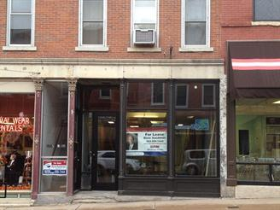

1. **Office equipment**

Pita Pit customers will be welcomed by our friendly employees. The restaurant is very clean and bright with plenty of room for customers to enjoy their food. The staff is very upbeat and happy to serve customers as well as knowledgeable about Pita Pit’s products and ingredients. Pita’s are made with the freshest ingredients, making them even healthier. Customers will enjoy their Pita Pit experience all in part to the friendly staff, fresh ingredients, and cleanness of the restaurant.

The interior of the new place will be similar to the other franchisees, because there should be some level of uniformity with the rest. Consistency between franchisees is very important and helps keep a good reputation within the businesses. Some pictures of the Chicago store can be found in the appendix.[12]

1. **Suppliers**

We will be working with A-Z Cleaning Solutions located here in Dubuque for our janitorial supply needs. <http://www.a-zcleaningsolutions.net/>

**HRM**

1. **Local Labor Market Conditions**

Employ college students and high-schoolers. There is over 10,000 college students from Loras College, University of Dubuque, Clark University and NICC. Pita Pit will pay the minimum wage to part-time workers, while there will only be one full employer, the COO, Jonathan Goodfellow.

**Financial Plan**

1. **Start-up Costs.**

The total start-up costs will be $157,450. All of these expenses should be covered during year zero, because all of them are necessary to be able to open the business.

|  |  |
| --- | --- |
| Expenses | Price |
| Initial Franchise Fee | $20,000 |
| Initial Rent and Security Deposit | **$11,939.40** |
| Opening Cash | **$500** |
| Leasehold Improvements | **$60,000** |
| Business License | **$200** |
| Insurance | **$1,500** |
| Daily Discipline Marketing Program Package | **$3,000** |
| Legan and Accouting Fees | **$500** |
| Initial Furniture, Fixtures, Equipment Package and Signage | **$20,000** |
| Staff & Management Training Expenses | **$1,000** |
| Uniforms | **$1,000** |
| Initial Inventory Package | **$10,000** |
| Total Initial Investment | **$127,700** |
| Additional Funds (for three months) | **$26,000** |
| Local Advertising | **$3,750\*** |
| Total Investment | **$157,450** |

**\*** Rules from the franchiser says each franchisee needs to spend at least 1% of total revenue for local advertisement.

1. **Accounting and Bookkeeping Systems[13]**

Pita Pit Dubuque will have an accountant, because the CFO, Juliana Lancheros will just be in charge of the overall expenses and she will not be present in the day-to-day business activities. Our accountant will be Ryan Burbach.

1. **Sales Forecast[14]**

The sales forecast is based on information given by Tom Cruise, CFO and owner of Pita Pit Mason City 50401, 616 S. Monroe Street. Tom Cruise is also the owner of Pita Pit Sioux City 51104, 2927 Hamilton Blvd, Unit 7A. We were also given advice by Erik Gerharter.

1. **Financials**

The executive team when trying to determine cash flows, income statements, and overall profitability of our company we used company benchmarking with other Pita Pits in similar demographic and geographic regions. The executive team spent intensive amounts of time making sure that the numbers produced on their statements would truly reflect what they believed was going to be accurate numbers and projections.

Most of the company benchmarking to develop the forecasting that was done to create Pita Dubuque LLC’s profit loss projections came from the opening of Pita Pit Sioux City. Being that Sioux City has very similar demographics and geographic the owner believed that Dubuque would be able to achieve as well if not better financial outcomes that he achieved. With the assistance of an owner of two Pita Pit franchised in the mid-west, the owner of Pita Pit in Flagstaff, Arizona, and the help of Pita Pit development aid from their corporate headquarters, the executive team understands that these numbers are going to be very accurate.

When the executive team created the profit loss statements on overall sales for the first year we used factual numbers from Pita Pit Sioux City. However, the estimated sales projections for the first year for Pita Pit Dubuque are slightly lower than Pita Pit Sioux City actual sales were. Therefor the executive team used percentages of profitability of 3 different Pita Pits and similar competitors and used in the Tri-State Area. With the understanding that every month is going to fluctuate in sales, the executive team has identified 3 periods a year of different sales: high sales period(November, July, August, and September), moderate sales period(October, December, January, and June), and low sales periods(February, March, April, and May). The executive team used percentages of sales for each of the assisting franchises and used those percentages to develop our overall cash flows. The profit loss statement is generated from like stated before, numerous different Pita Pits, and area competitors to develop the most accurate numbers available.

The executive team estimates that Pita Pit Dubuque will do $410,000 in sales the first year in operation. That being said the business plans to continue to grow over the course of the first three years. The company plans to expand sales 14% a year for the first three years. The company will take payments of cash, and credit. Our credit card agreements are going to cost $900 a month total to all the credit companies we are going to be involved with (Visa, MasterCard, American Express, Discover).

To achieve our overall capital investment the COO and GM, Jonathan Goodfellow’s grandparents Joe and Nacy Donlon are going to invest $62,980 cash. In agreement to repay in ten years with 5.5% interest with no penalty to repay early. The remainder of the funds for the start-up are going to be provided by a loan from U.S.Bank Dubuque which will amount to $94,470 at 3.9% interest also with no penalty to repay early.

In order to repay our investors and loan to the bank the executive team has created a competitive edge with good profit margins to make the money happen and happen quickly to turn profits and revenue quickly. Every product that Pita Pit is going to be selling will vary on profit margin. The big picture is how Pita Pit Dubuque stands on average with total markups. For example a bottle of our water has a 140% markup and our extremely fresh lettuce has 6%. Understanding that we need to drive costs of operation down and sales up the team is achieving a 20% overall profit margin on all products. These numbers are just the starting point and the executive team is planning on in our first three years of operation achieving 25% overall gross profit margin

Once the business is up and running in May of 2014 Stephanie, Juliana, and Ryan will take our leave from directly working with the organization and remain executive decision makers on the board of directors.  They will receive compensation as owners, but will not be involved in the day to day activities. Jon will remain as the manager and will be in charge of the day to day operations. He will earn a salary of $32,000 a year, in addition to his earnings as an owner.

**NOTE: all information provided to the SBDC will be treated as confidential material**

**APPENDIX**

**Competitors:**

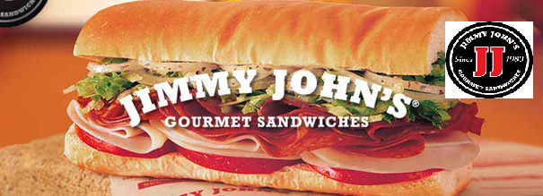

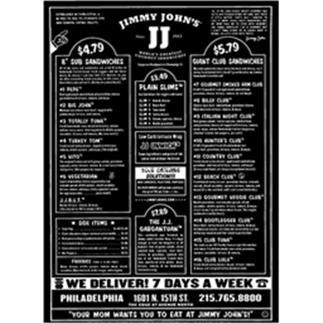“At Jimmy John’s, vegetables are brought from the fields to the packer to the shipper to my restaurants. They are unpacked, washed, sliced and served to you. They are genuinely fresh - this is my definition of fresh. From the field to the truck to the store to the slicer to your sandwich. That’s why mine taste better, they are made with fresher stuff. My definition of fresh and their definition of fresh are significantly different.” (Jimmy Johns)

**Jimmy Johns’ Menu**

Distance from Pita Pit Dubuque to Jimmy Johns Dubuque. 0.1 mile distance between both locations, so this restaurant will be our biggest competitor.

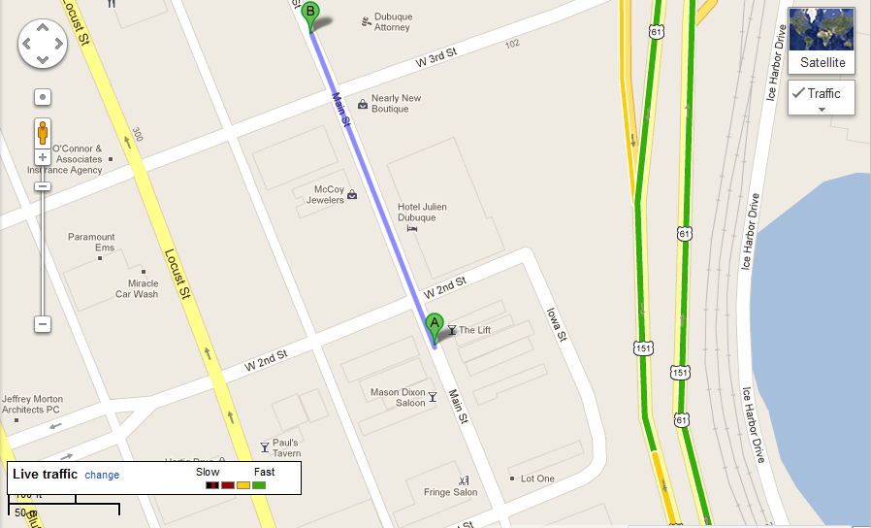

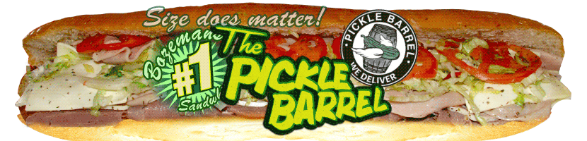

1. Panera Bread: Over 1,230 locations nationwide (and in Canada)
   1. Catering
   2. Menu: <http://www.panera-iowa.com/fax%20menus/BC/3202.pdf>
   3. Range from $5.99 to $8.79 for Panini
   4. 1,652 locations in 44 states and Canada.
2. Noodles and Company: 204 locations in West, Midwest, South
   1. Range from $5.99 to $6.99
   2. Choose between American, Mediterranean, and Asian food
   3. Not international
3. Subway:
   1. Catering
   2. Range from $3.50 for 6 inch and $6.75 for footlong
   3. Menu: <http://mylocal.subway.com/socal/images/Takout_Menu_2012.pdf>
   4. International

* Pita Pit
  + Meat pita
  + Vegetarian pita 🡪 <http://www.health.com/health/article/0,,20411588_last,00.htm>
  + Menu: <http://www.unh.edu/dining/locations/menus/menu_pita_pit.html>
  + Prices range from $3.99 to $6.39
  + International
* **Data of Colleges and Universities in Dubuque, IA**

1. Loras College: 1,600 students

<http://www.loras.edu/About-Loras/Loras-at-a-Glance.aspx>

1. Clarke University: 1,191 students

<http://www.clarke.edu/page.aspx?id=44>

1. University of Dubuque: 2,013 students

<http://alumni.dbq.edu/?udfastfacts>

1. NICC: 5,000 students

<https://www.nicc.edu/aboutnicc/collegeprofile/>

**Location**

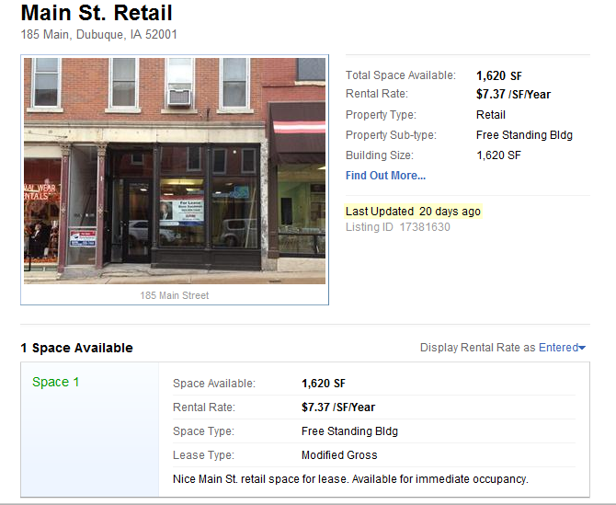

**General Layout of a Pita Pit Store.**

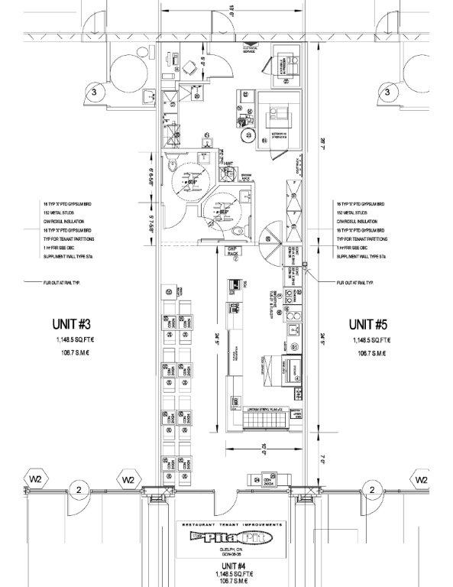

**Customer Experience** (These images were taken from the Pita Pit in Chicago, IL.)

* **Address:** 2404 N Lincoln Ave, Chicago, IL 60614
* **Phone:**(773) 935-7482
* **Hours:** Tuesday hours 11:00 am–12:00 am
  + - 1. This is what all of our customers will find as soon as they open the door of our location. There will be a sign hanging from the ceiling that will indicate where to order.

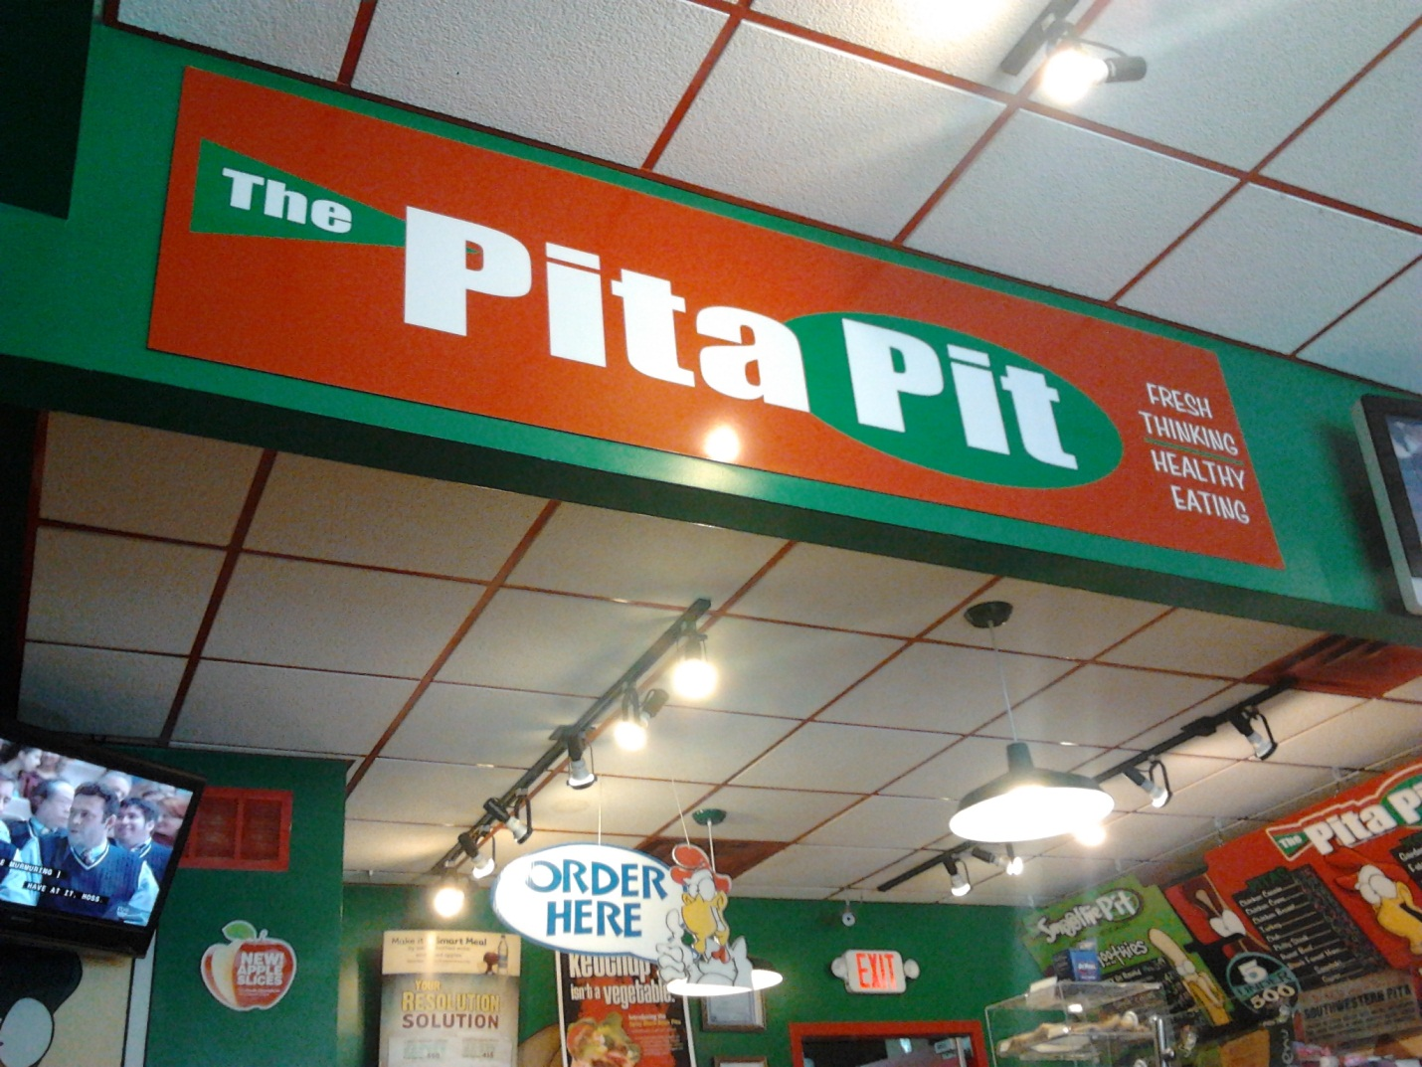

* + - 1. Counter. All ingredients will be found in this area. Customers will be able to indicate their choices of preferences for their pitas.

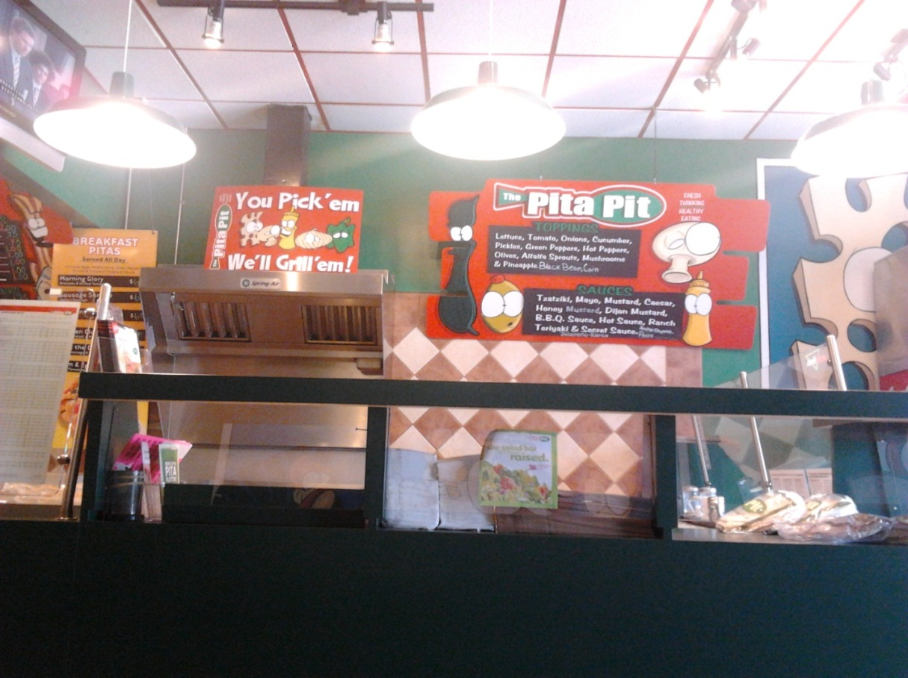

* + - 1. 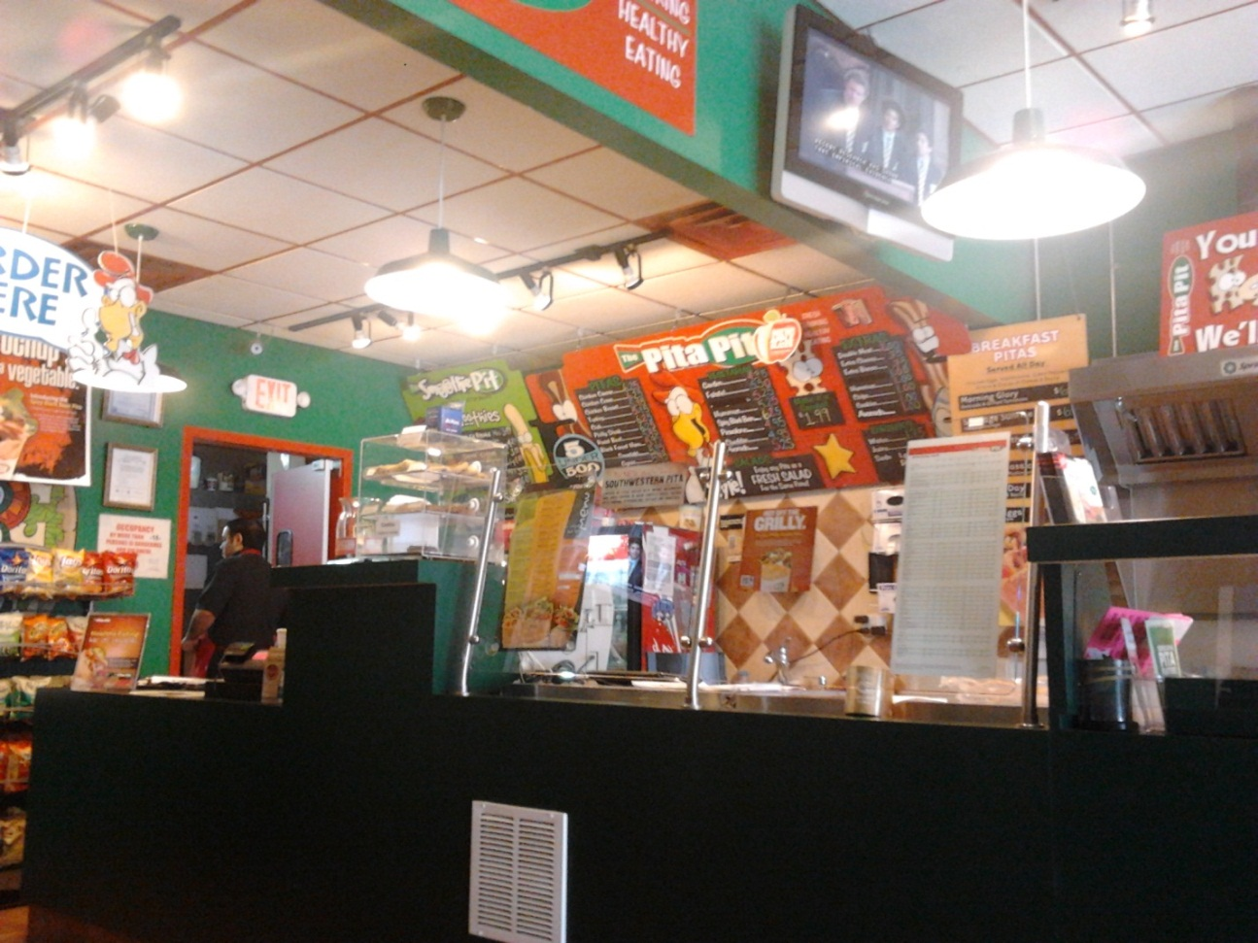View from the seating area.

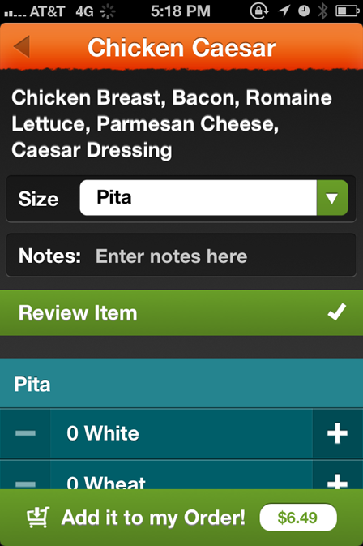**Applications for Smartphones**

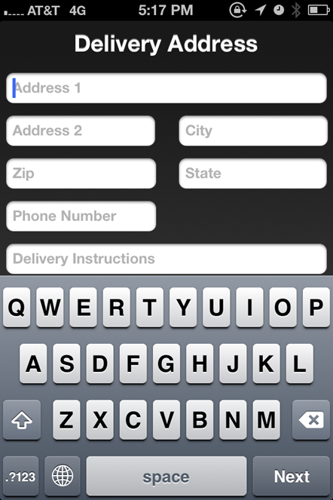

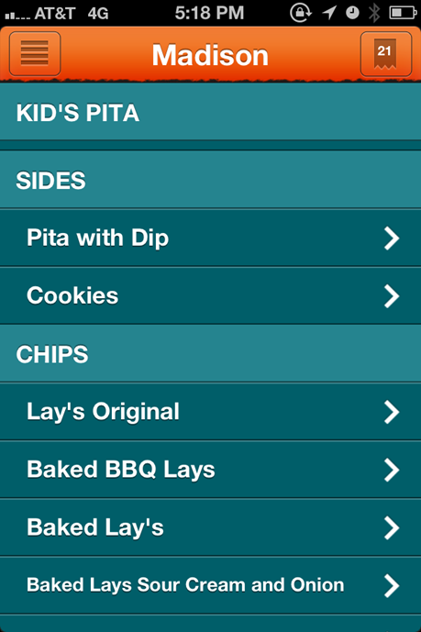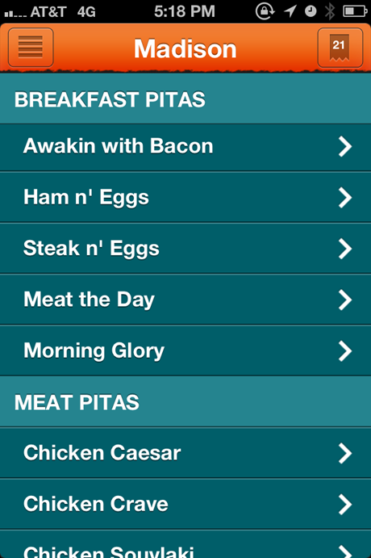

**Expenses Chart**

|  |  |  |  |  |  |  |  |  |  |  |  |  |  |
| --- | --- | --- | --- | --- | --- | --- | --- | --- | --- | --- | --- | --- | --- |
| **Pita Pit _ Dubuque** |  |  |  |  |  |  |  |  |  |  |  |  |  |
|  |  |  |  |  |  |  |  |  |  |  |  |  |  |
| **Fiscal Year Begins** |  |  |  |  |  |  |  |  |  |  |  |  |  |
|  |  |  |  |  |  |  |  |  |  |  |  |  |  |
| **177 customers a day @ $7.00** | **Nov-09** | **Dec-09** | **Jan-10** | **Feb-10** | **Mar-10** | **Apr-10** | **May-10** | **Jun-10** | **Jul-10** | **Aug-10** | **Sep-10** | **Oct-10** | **YEARLY** |
| **Expenses** |  |  |  |  |  |  |  |  |  |  |  |  |  |
| **Payroll expenses** | **8,800** | **7,700** | **7,700** | **7,500** | **7,200** | **7,200** | **7,200** | **7,700** | **7,700** | **8,200** | **8,200** | **7,700** | **92,800** |
| **Payroll taxes** | **656** | **578** | **578** | **540** | **540** | **540** | **540** | **578** | **578** | **615** | **615** | **578** | **6,936** |
| **Outside services** | **300** | **300** | **300** | **300** | **300** | **300** | **300** | **300** | **300** | **300** | **300** | **300** | **3,600** |
| **Supplies (office and operating)** | **200** | **200** | **200** | **250** | **250** | **250** | **250** | **200** | **200** | **200** | **200** | **200** | **2,600** |
| **Repairs and maintenance** | **100** | **100** | **100** | **100** | **100** | **100** | **100** | **100** | **100** | **100** | **100** | **100** | **1,200** |
| **Advertising** | **1,500** | **1,000** | **1,000** | **800** | **800** | **800** | **800** | **1,000** | **1,000** | **1,500** | **1,500** | **1,000** | **12,700** |
| **Car, delivery and travel** | **400** | **400** | **400** | **400** | **400** | **400** | **400** | **400** | **400** | **400** | **400** | **400** | **4,800** |
| **Accounting and legal** | **150** | **150** | **150** | **150** | **150** | **150** | **150** | **150** | **150** | **150** | **150** | **150** | **1,800** |
| **Rent $20 including NNN** | **3,465** | **3,465** | **3,465** | **3,465** | **3,465** | **3,465** | **3,465** | **3,465** | **3,465** | **3,465** | **3,465** | **3,465** | **41,580** |
| **Telephone** | **50** | **50** | **50** | **50** | **50** | **50** | **50** | **50** | **50** | **50** | **50** | **50** | **600** |
| **Utilities** | **800** | **800** | **800** | **800** | **800** | **800** | **800** | **800** | **800** | **800** | **800** | **800** | **9,600** |
| **Insurance** | **300** | **300** | **300** | **300** | **300** | **300** | **300** | **300** | **300** | **300** | **300** | **300** | **3,600** |
| **Taxes (real estate, etc.)** |  |  |  |  |  |  |  |  |  |  |  |  | **0** |
| **Interest** |  |  |  |  |  |  |  |  |  |  |  |  | **0** |
| **Depreciation** |  |  |  |  |  |  |  |  |  |  |  |  | **0** |
| **SBA loan** | **2,110** | **2,110** | **2,110** | **2,110** | **2,110** | **2,110** | **2,110** | **2,110** | **2,110** | **2,110** | **2,110** | **2,110** | **25,320** |
| **Cable TV, internet** | **100** | **100** | **100** | **100** | **100** | **100** | **100** | **100** | **100** | **100** | **100** | **100** | **1,200** |
| **Royalties** | **1,600** | **1,400** | **1,400** | **1,280** | **1,200** | **1,280** | **1,280** | **1,400** | **1,400** | **1,600** | **1,600** | **1,400** | **16,840** |
| **Misc. (unspecified)** | **250** | **250** | **250** | **250** | **250** | **250** | **250** | **250** | **250** | **250** | **250** | **250** | **3,000** |
| **Total Expenses** | **20,781** | **18,903** | **18,903** | **18,395** | **18,015** | **18,095** | **18,095** | **18,903** | **18,903** | **20,140** | **20,140** | **18,903** | **228,176** |
|  |  |  |  |  |  |  |  |  |  |  |  |  |  |
| **Net Profit** | **-20,781** | **-18,903** | **-18,903** | **-18,395** | **-18,015** | **-18,095** | **-18,095** | **-18,903** | **-18,903** | **-20,140** | **-20,140** | **-18,903** | **-228,176** |

**Profit and Loss Forcast**

|  |  |  |  |  |  |  |  |  |  |  |  |  |  |
| --- | --- | --- | --- | --- | --- | --- | --- | --- | --- | --- | --- | --- | --- |
| **Profit and Loss Projection (12 Months)** | | | | | | | | | | | | | |
|  |  |  |  |  |  |  |  |  |  |  |  |  |  |
| **Fiscal Year Begins** |  |  |  |  |  |  |  |  |  |  |  |  |  |
|  |  |  |  |  |  |  |  |  |  |  |  |  |  |
| **177 customers a day @ $7.00** | **Nov-09** | **Dec-09** | **Jan-10** | **Feb-10** | **Mar-10** | **Apr-10** | **May-10** | **Jun-10** | **Jul-10** | **Aug-10** | **Sep-10** | **Oct-10** | **YEARLY** |
| **Revenue (Sales)** |  |  |  |  |  |  |  |  |  |  |  |  |  |
| **Food Sales** | **34,276** | **29,946** | **29,946** | **27,421** | **25,617** | **27,421** | **27,421** | **29,946** | **29,946** | **34,276** | **34,276** | **29,946** | **360,439** |
| **Soft Drink Sales** | **4,674** | **4,084** | **4,084** | **3,739** | **3,493** | **3,739** | **3,739** | **4,084** | **4,084** | **4,674** | **4,674** | **4,084** | **49,151** |
|  |  |  |  |  |  |  |  |  |  |  |  |  |  |
| **Total Revenue (Sales)** | **38,950** | **34,030** | **34,030** | **31,160** | **29,110** | **31,160** | **31,160** | **34,030** | **34,030** | **38,950** | **38,950** | **34,030** | **409,590** |
|  |  |  |  |  |  |  |  |  |  |  |  |  |  |
| **Cost of Sales** |  |  |  |  |  |  |  |  |  |  |  |  |  |
| **Food** | **13,376** | **11,704** | **11,704** | **10,701** | **10,032** | **10,701** | **10,701** | **11,704** | **11,704** | **13,376** | **13,376** | **11,704** | **140,783** |
| **Soft Drink** | **1,200** | **1,260** | **1,260** | **1,152** | **1,080** | **1,152** | **1,152** | **1,260** | **1,260** | **1,200** | **1,200** | **1,260** | **14,436** |
| **Total Cost of Sales** | **14,576** | **12,964** | **12,964** | **11,853** | **11,112** | **11,853** | **11,853** | **12,964** | **12,964** | **14,576** | **14,576** | **12,964** | **155,219** |
|  |  |  |  |  |  |  |  |  |  |  |  |  |  |
| **Gross Profit** | **24,374** | **21,066** | **21,066** | **19,307** | **17,998** | **19,307** | **19,307** | **21,066** | **21,066** | **24,374** | **24,374** | **21,066** | **254,371** |
|  |  |  |  |  |  |  |  |  |  |  |  |  |  |
| **Expenses** |  |  |  |  |  |  |  |  |  |  |  |  |  |
| **Payroll expenses** | **8,800** | **7,700** | **7,700** | **7,500** | **7,200** | **7,200** | **7,200** | **7,700** | **7,700** | **8,200** | **8,200** | **7,700** | **92,800** |
| **Payroll taxes** | **656** | **578** | **578** | **540** | **540** | **540** | **540** | **578** | **578** | **615** | **615** | **578** | **6,936** |
| **Outside services** | **300** | **300** | **300** | **300** | **300** | **300** | **300** | **300** | **300** | **300** | **300** | **300** | **3,600** |
| **Supplies (office and operating)** | **200** | **200** | **200** | **250** | **250** | **250** | **250** | **200** | **200** | **200** | **200** | **200** | **2,600** |
| **Repairs and maintenance** | **100** | **100** | **100** | **100** | **100** | **100** | **100** | **100** | **100** | **100** | **100** | **100** | **1,200** |
| **Advertising** | **1,500** | **1,000** | **1,000** | **800** | **800** | **800** | **800** | **1,000** | **1,000** | **1,500** | **1,500** | **1,000** | **12,700** |
| **Car, delivery and travel** | **400** | **400** | **400** | **400** | **400** | **400** | **400** | **400** | **400** | **400** | **400** | **400** | **4,800** |
| **Accounting and legal** | **150** | **150** | **150** | **150** | **150** | **150** | **150** | **150** | **150** | **150** | **150** | **150** | **1,800** |
| **Rent $20 including NNN** | **3,465** | **3,465** | **3,465** | **3,465** | **3,465** | **3,465** | **3,465** | **3,465** | **3,465** | **3,465** | **3,465** | **3,465** | **41,580** |
| **Telephone** | **50** | **50** | **50** | **50** | **50** | **50** | **50** | **50** | **50** | **50** | **50** | **50** | **600** |
| **Utilities** | **800** | **800** | **800** | **800** | **800** | **800** | **800** | **800** | **800** | **800** | **800** | **800** | **9,600** |
| **Insurance** | **300** | **300** | **300** | **300** | **300** | **300** | **300** | **300** | **300** | **300** | **300** | **300** | **3,600** |
| **Taxes (real estate, etc.)** |  |  |  |  |  |  |  |  |  |  |  |  | **0** |
| **Interest** |  |  |  |  |  |  |  |  |  |  |  |  | **0** |
| **Depreciation** |  |  |  |  |  |  |  |  |  |  |  |  | **0** |
| **SBA loan** | **2,110** | **2,110** | **2,110** | **2,110** | **2,110** | **2,110** | **2,110** | **2,110** | **2,110** | **2,110** | **2,110** | **2,110** | **25,320** |
| **Cable TV, internet** | **100** | **100** | **100** | **100** | **100** | **100** | **100** | **100** | **100** | **100** | **100** | **100** | **1,200** |
| **Royalties** | **1,600** | **1,400** | **1,400** | **1,280** | **1,200** | **1,280** | **1,280** | **1,400** | **1,400** | **1,600** | **1,600** | **1,400** | **16,840** |
| **Misc. (unspecified)** | **250** | **250** | **250** | **250** | **250** | **250** | **250** | **250** | **250** | **250** | **250** | **250** | **3,000** |
| **Total Expenses** | **20,781** | **18,903** | **18,903** | **18,395** | **18,015** | **18,095** | **18,095** | **18,903** | **18,903** | **20,140** | **20,140** | **18,903** | **228,176** |
|  |  |  |  |  |  |  |  |  |  |  |  |  |  |
| **Net Profit** | **3,593** | **2,163** | **2,163** | **912** | **-17** | **1,212** | **1,212** | **2,163** | **2,163** | **4,234** | **4,234** | **2,163** | **26,195** |

**Pita Pit**

**Menu**

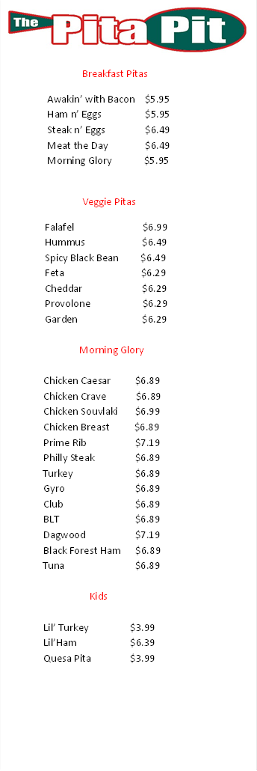

**Facebook**

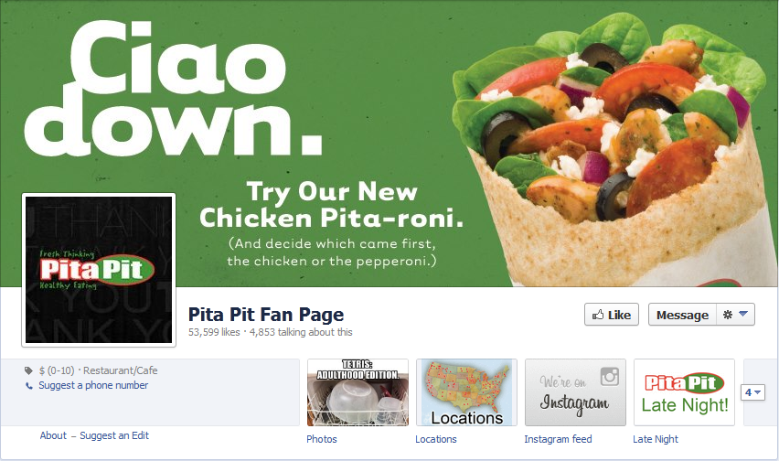

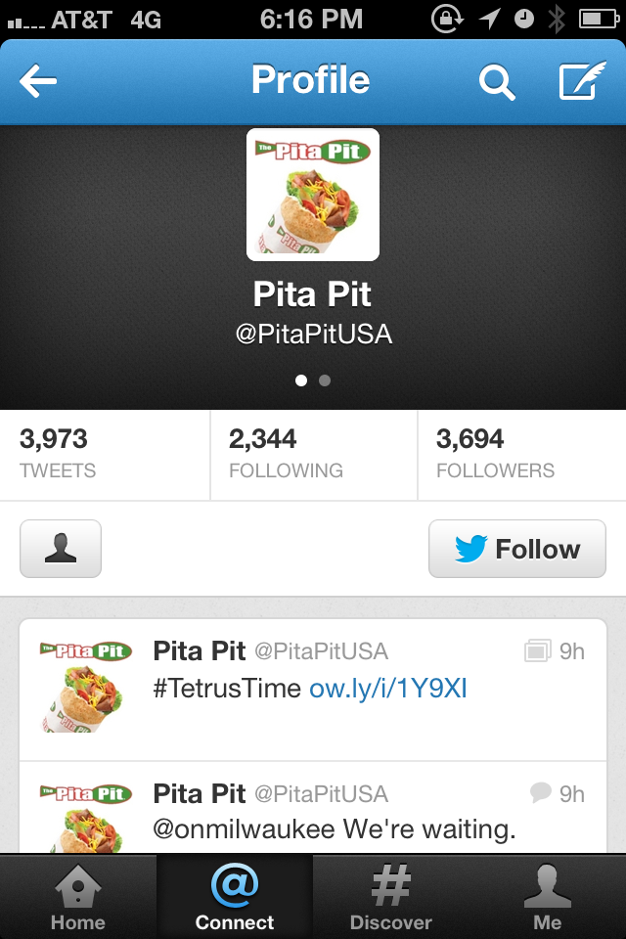

**Twitter**

**Works Cited**

“Bakery-Cafe Menu. Panera Bread.” N.p., 27 Feb 2013. Web. <http://www.panera-iowa.com/fax menus/BC/3202.pdf>.

“Dubuque Crime Rates.” Neighborhood Scout.” Location Inc. Web. <http://www.neighborhoods cout.com/ia/dubuque/crime/>.

“Dubuque, IA Historical Employment Status Data.” USA.com. World Media Group, LLC. Web. <http://www.usa.com/dubuque-ia-income-and-careers--historical-employment-status-data.htm>.

“Dubuque, IA Janitorial Supplies and Equipment.” A-Z Cleaning Solutions. Yellow Book USA, Inc. Web. <http://www.a-zcleaningsolutions.net/>.

“Fact Sheet – Fiscal Year 2011-2012.” UD Facts. University of Dubuque. Web. <http://alumni. dbq.edu/?udfastfacts>.

“Find A Pita Pit Location." My Pita Pit Card. Pita Pit USA Inc. Web. <https://www.mypitapit card.com/locations?field_state_value=IA&field_city_value=>.

“Jimmy John's ." Jimmy John's Gourmet Sanwiches. Jimmy John's Franchise, LLC. Web. <http://www.jimmyjohns.com/homepage.asp&xgt>.

“Jimmy Johns Menu." Roblox. ROBLOX Corporation, 3 Jun 2011. Web. <http://www.roblox. com/Jimmy-Johns-Menu-item?id=53149025>.

“Loras At A Glance." Loras College. Web. <http://www.loras.edu/About-Loras/Loras-at-a-Glance.asp&xgt;.

“Menu & Catering." Subway. Doctor. Web. <http://mylocal.subway.com/socal/images/Takout _Menu_2012.pdf>.

Minkin, Tracy. "America's Top 10 Healthiest Fast Food Restaurants." Health. 19 Feb 2009: n. page. Print.

“College Profile." Northeast Iowa Community College. Web. <https://www.nicc.edu/ aboutnicc/collegeprofile/>.

“Pit Card." My Pita Pit Card. Pita Pit USA Inc. Web. <https://www.mypitapitcard.com/>.

“Pita Pit Menu." University of New Hampshire: Dining Services. UNH Dining. Web. <http://www.unh.edu/dining/locations/menus/menu_pita_pit.html>.

“Quick Facts." Clarke University. Web. <http://www.clarke.edu/page.aspx?id=44>.

Sioux Falls. The Pickle Barrel. Pickle Barrel, n.d. Web. <http://www.picklebarrelmt. com/ aboutus_siouxfalls.html>.

1. Pita Pit Franchiser includes children as their target market, because Pita Pit has a family friendly atmosphere.
2. Dubuque, IA Historical Employment Status Data.
3. “Dubuque Crime Rates.”
4. Found in Pita Pit Franchisor’s webpage is “Pit Card."
5. Menu found in the appendix page: “Jimmy Johns Menu."
6. Menu with our products and prices can be found in the appendix on page 45“Pita Pit Menu."
7. Web sites found in the Works Cited Page.
8. Screenshots of Apps found in the appendix page: 38.
9. Screenshots of those pages are found in the appendix page: 46
10. More detailed information found in the Profit and Loss Table, appendix page: 41
11. Menu with our products and prices can be found in the appendix on page 45“Pita Pit Menu."
12. Pictures are found in the appendix page 35.
13. See charts of expenses in the appendix page 39.
14. See profit and loss projections in the chart in the appendix page 41.